Content and Language Integrated Learning: An Introduction
(CLIL 1 Course)

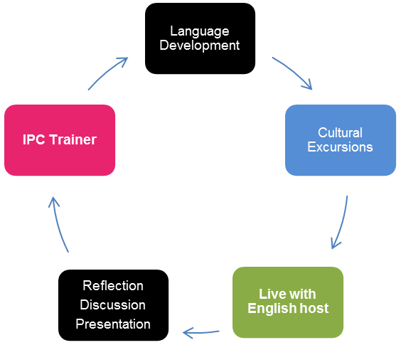
This interactive, experiential course has been specifically designed for secondary subject teachers who teach their subject in the medium of English. Course participants will need at least an Intermediate level of English (B1+). The 2 week course comprises 38 hours of classroom tuition and excursions to places of interest. For teachers interested in working in a multi-partner school project in which the working language is English, this course is a good starting point and potentially a good place to meet partner teachers from different countries. In this context the training can support your school’s European Development Plan.

Programme Includes
- Accommodation with a homestay host (bed, breakfast, packed lunch, evening meal each day)
- Met by your homestay host on arrival in Exeter
- Bus pass for all local travel in the Exeter area
- Course content may be negotiated in advance by a group organiser
- 38 hours training over 2 weeks
- Course content tailored to each group
- Town tour of Exeter on first Monday afternoon
- Guided excursions to places of local cultural significance
- Assistance with completing your Europass Mobility documents
- Attendance certificate

Classroom sessions feature:
- Language development activities
- Features and rationale of CLIL
- Teaching, learning and revising vocabulary
- Learner training techniques
- Classroom language/teacher talk
- Use of websites and resources
- Phonology, speaking and communication skills
- British Education system and comparisons
- Preparation, design and evaluation of materials
- Delivering a collaborative course task with a colleague or colleagues (including planning time)
- Giving constructive feedback
- Practical ideas for the CLIL classroom
- Assessment in the CLIL classroom
- Reflective practice

Who is this course for?
- IPC’s CLIL 1 course is for secondary subject teachers (non-specialist English teachers) who are teaching or who will be teaching using English as the language of the classroom.
- IPC’s CLIL 1 course is for teachers who enjoy working in a cooperative and collaborative learning environment.
- IPC’s CLIL 1 course is for teachers who would like to meet colleagues from other countries in Europe to set up partnerships for example.
- IPC’s CLIL 1 course is for teachers who have a minimum English level of Intermediate (B1+), so they can fully exploit not only their course but their time in Exeter.
- IPC’s CLIL 1 course is for teachers who are seeking to maintain student engagement and keep their students in education.
Supporting Your School’s European Development Plan
- These courses support staff (continuing) professional development in terms of
  - Improving linguistic competence.
  - Enhancing professional skills, knowledge e.g. awareness of/application of new/unfamiliar student-centred teaching approaches/methods.
- These courses provide teachers (a school) with the opportunity to initiate school partnerships to enhance the on-going learning experience of pupils/students/learners.
- Participating staff will become more interculturally aware through meeting colleagues from other countries as well as being in the United Kingdom.
- Participating teachers will gain knowledge of the British and colleagues’ education systems.
- IPC has been delivering quality teacher training courses since 1993 and is accredited by the British Council and is a member of English UK. IPC can help in the planning stage of your staff mobility project by for example arranging accommodation, assisting with travel arrangements (and completion of Europass Mobility documentation during your staff mobility project).
- Organisations will gain a more European/international perspective/profile.
- Organisations will benefit from teachers integrating their experience(s) into their school/local community.

What happens on a CLIL Secondary course?
Working with your trainer(s) and fellow course participants:

- You will have opportunities to discuss factors which influence your teaching situation.
- You will experience learning activities which incorporate CLIL methodology first hand, allowing you to develop a greater understanding of delivering a course using CLIL methodology as well as giving you practical teaching ideas that you can use in your classroom.
- There will be opportunities to develop/improve/refresh your own English skills and knowledge.
- You will have an opportunity to explore the local area, with an IPC guide on escorted trips to places of interest – experience language in its cultural and social setting.
- You will put course content into practice by delivering a course task with a colleague or colleagues to your fellow course participants – experiment with something new.

How should I prepare for a CLIL Secondary course?
To help you get the most from participating on your CLIL course you will be advised how to prepare for your course. To consolidate your CLIL course upon your return home you will be advised how you can follow up your course.

Sample Programme
 | Morning  Session |  |  |  | Afternoon  Session
Sunday | Travel to Exeter. Met on arrival by homestay host. Evening meal with homestay host.
Monday | Introduction to IPC and course. Needs Analysis. |  |  | Tour of Exeter with your IPC Guide
Tuesday | Features and Rationale of CLIL |  |  | Personal Language Development via CLIL Activities
Wednesday | Language Development via CLIL Activities |  |  | Non-Classroom Based Activity e.g. trip
Thursday | Vocabulary Workshop |  |  | Practical Ideas/Resources
Friday | Language Development via CLIL Activities, Focussing on Developing Skills |  |  | Free Afternoon
Saturday | Guided day trip to Tintagel and Boscastle with your IPC Guide
Sunday | Free day to spend with your homestay host or make your own plans
Monday | Classroom Language. Personal Language Development |  |  | Practical ideas
Tuesday | British Education System |  |  | Assessment in the CLIL Classroom
Wednesday | Introduction of Course Task and Preparation Time |  |  | Non-Classroom Based Activity e.g. trip
Thursday | Delivering Course Task and Feedback. |  |  | Practical Ideas
Friday | Personal Language Development. Course Closure. |  |  | Free Afternoon
Saturday | Travel home

