Practical Ideas for the Primary Classroom (PIP)

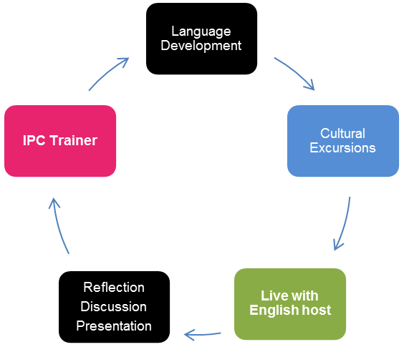
This interactive, experiential course has been specifically designed for teachers who work with nursery or primary aged students of the age range 4-11 who would like to inject some fresh energy into their teaching practice. Course participants will need at least an intermediate level of English (B1+). The 2 week course comprises 38 hours of classroom tuition and excursions to places of interest. For teachers interested in working in a multi-partner school project in which the working language is English, this course is a good starting point and potentially a good place to meet partner teachers from different countries. In this context the training can support your school’s European Development Plan.

Programme Includes
- Accommodation with a homestay host (bed, breakfast, packed lunch, evening meal each day)
- Met by your homestay host on arrival in Exeter
- Bus pass for all local travel in the Exeter area
- 38 hours training over 2 weeks
- Course content tailored to each group
- Course content may be negotiated in advance by a group organiser
- Town tour of Exeter on first Monday afternoon
- Guided excursions to places of local cultural significance
- Assistance with completing your Europass Mobility documents
- Attendance certificate

Classroom sessions feature:
- Personal language development activities
- Child learning and development theories
- Learning styles and multi-sensory learning
- Motivating young learners
- Preparation, design and evaluation of materials
- Use of new technologies in the primary classroom
- Cross-curricular activities
- Developing thinking skills
- British education system and comparisons
- Practical ideas for the primary classroom
- Assessment in the primary classroom and giving constructive feedback
- Delivering a collaborative course task with a colleague or colleagues (with preparation time)
- Reflective teaching practice

Who is this course for?
- IPC’s PIP course is for primary school teachers who teach English or who teach via the medium of English.
- IPC’s PIP course is for primary school teachers who would like to expand and update their teaching repertoire.
- IPC’s PIP course is for teachers who enjoy working in a cooperative and collaborative learning environment.
- IPC’s PIP course is for teachers who would like to meet colleagues from other countries in Europe to set up partnerships for example.
- IPC’s PIP course is for teachers who have a minimum English level of Intermediate (B1+), so they can fully exploit not only their course but their time in Exeter.
- IPC’s PIP course is for teachers who are looking to maximise pupil engagement at this early stage of their education.

Supporting Your School’s European Development Plan
- This course supports staff (continuing) professional development in terms of
  - Improving linguistic competence.
  - Enhancing professional skills, knowledge e.g. awareness of/application of new/unfamiliar student-centred teaching approaches/methods.
- This course provides teachers (a school) with the opportunity to initiate school partnerships to enhance the on-going learning experience of pupils/students/learners.
- Participating staff will become more interculturally aware through meeting colleagues from other countries as well as being in the United Kingdom.
- Participating teachers will gain knowledge of the British and colleagues’ education systems.
- IPC has been delivering quality teacher training courses since 1993 and is accredited by the British Council and is a member of English UK. IPC can help in the planning stage of your staff mobility project by for example arranging accommodation, assisting with travel arrangements (and completion of Europass Mobility documentation during your staff mobility project).
- Organisations will gain a more European/international perspective/profile.
- Organisations will benefit from teachers integrating their experience(s) into their school/local community.

What happens on a PIP course?
Working with your trainer(s) and fellow course participants:
- You will have opportunities to discuss factors which influence your teaching situation.
- You will experience learning activities which use a variety of different methodologies, allowing you to develop a greater understanding of learning theories as well as giving you practical teaching ideas that you can use in your classroom.
- There will be opportunities to develop/improve/refresh your own English skills and knowledge.
- You will have an opportunity to explore the local area, with an IPC guide on escorted trips to places of interest – experience language in its cultural and social setting.
- You will put course content into practice by delivering a course task with a colleague or colleagues to your fellow course participants – experiment with something new.

How should I prepare for a PIP course?
To help you get the most from participating on your PIP course you will be advised how to prepare for your course. To consolidate your PIP course upon your return home you will be advised how you can follow up your course.

Sample Programme
 | Morning  Session |  |  |  | Afternoon  Session
Sunday | Travel to Exeter. Met on arrival by homestay host. Evening meal with homestay host.
Monday | Introduction to IPC and Course; Needs Analysis. |  |  | Tour of Exeter with your IPC Guide
Tuesday | Learning Theories |  |  | Personal Language Development
Wednesday | Learning Styles and Cycles |  |  | Non-Classroom Based Activity e.g. trip
Thursday | Digital Technologies in the Primary Classroom |  |  | Cross-Curricular Activities
Friday | Creating Engaging Materials |  |  | Free Afternoon
Saturday | Guided day trip to Tintagel and Boscastle with your IPC Guide
Sunday | Free day to spend with your homestay host or make your own plans
Monday | Personal Language Development |  |  | Practical Ideas for the Primary Classroom
Tuesday | British Education System |  |  | Practical Ideas for the Primary Classroom
Wednesday | Introduction of Course Task and Preparation Time |  |  | Non-Classroom Based Activity e.g. trip
Thursday | Assessment in the Primary Classroom |  |  | Course Task delivery and Feedback
Friday | Personal Language Development and  Course Closure Activities |  |  | Free Afternoon
Saturday | Travel home

