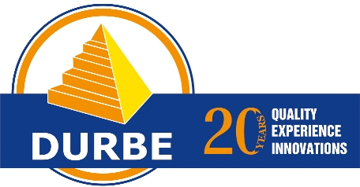 | RUSSIAN LANGUAGE ACADEMY  COURSE OFFER FOR TEACHERS  www.russian-academy.com  russian@durbe.edu.lv

RUSSIAN TEACHERS DEVELOPMENT COURSE

The Russian Teachers Development Course has been created for non-native speakers of Russian teaching at primary, secondary, vacational schools, colleges and universities or language centrs for adults at Beginners, Elementary and Intermediate levels. It is recommended that the participants have a level of Russian at CEF level no less than B1 (B1, B1+, B2 or B2+). The participants can choose to study 1 or 2 weeks.
RLA Durbe – receiving partner school of
ERASMUS+ academic mobility programme!
Erasmus+ provides full funding opportunities for specialized and language courses.
The list of National Agencies managing Erasmus+ program can be found here.

Objectives: To master language training, learning and teaching methodologies. The focus will be on teaching techniques of a foreign language without translation but by the help of explanation.
Outcome: Russian Teachers Development course will improve your confidence in lesson delivery and expand your range of methodological approaches to enhance classroom practice.

During the course the following methodology topics are covered:
Week 1
Monday | Tuesday | Wednesday | Thursday | Friday
Specifics of Russian as a foreign language teaching to beginners. Student books and workbooks available for learning the language. | Formation of correct pronunciation styding Russian as a foreign language. Songs as a method for improving and mastering pronunciation. | Classroom management, types of motivation. Resources for teaching online. | How to develop listening skills by the help of phonetic exercises. | Methods and techniques of developing reading skills and comprehension. How to guess the meaning of the new words from the context.

Week 2
Monday | Tuesday | Wednesday | Thursday | Friday
The development of lexis in Russian as a foreign language classroom. How to develop communicative competence and facilitate group discussions. | Elements of game in developing grammar awareness. Work with texts can be exciting. | The development of writing skills, the variety of styles. How to extend and develop thinking skills. | The use of interactive methods and internet resources in learning Russian as a foreign language. | The ways of testing knowledge, different tests and exams. Original way of using TV news in the teaching process.
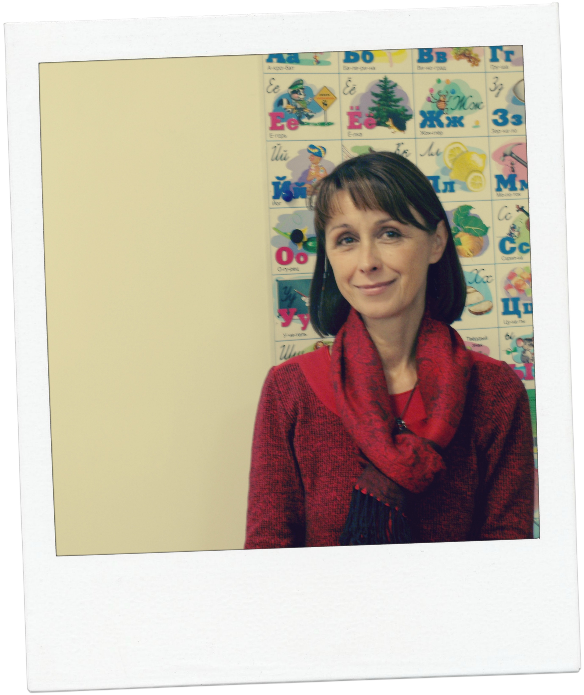
Hana Polisenska /Czech Republic/: „Latvia is one of the few European countries, where at Durbe Russian Language Academy it is possible to study through Erasmus+ funded courses for Teacher’s Development. As a teacher of Russian language, I loved the communication skills practice, the structure of lessons and the variety of useful links and facts provided about the methods of teaching Russian as a foreign language. Latvia left a wonderful impression on me, and I discovered Riga as an elegant and interesting city where I felt stress-free and very calm.”
FACTS ABOUT RUSSIAN TEACHERS DEVELOPMENT COURSES:

Number of lessons: 15 lessons per week
Course takes place in the afternoons from 13.30 to 16.10.
Maximum class size: 12 participants
Combination with Standard or Individual Russian course is available, prices upon request.
Registration fee: 90 EUR

Length / Number of lessons | Prices | Dates in July 2020 | Dates in August 2020
1 week / 15 lessons in total | 340 EUR | July 6 – 10 or July 13 - 17 | August 3 – 7 or August 10 - 14
2 weeks / 30 lessons in total | 680 EUR | July 6 - 17 | August 3 - 14

Additional optional services: accommodation (host families, residence, shared flats or 3* hotel), airport transfers.

STUDY RUSSIAN IN LATVIA!

WHY RLA Durbe?
- Located in the heart of Riga centre
- Internationaly accredited by EAQUALS, accredited Telc exam centre
- First private language school in Latvia recognized by the Ministry of Education and Science of Latvia
- Extensive diversity of the courses offered (groups, mini groups, one to one, Vacation club 50+, military)
- Small classes with maximum of 8 students (in summer up to 10) for all levels
- Highly professional and enthusiastic teachers

WHY Latvia?
- No VISA for citizens of the EU, USA, Canada, Japan, Brazil, South Korea and other countries
- Direct low cost flights from many destinations (RyanAir, WizzAir, AirBaltic)
- Bilingual country: explore Russian and Latvian culture and traditions
- Country of castles, white sandy beaches, unique architecture and safe environment

WHY Riga?
- Riga’s Old Town is a UNESCO World Heritage Site
- Tourists highly appreciate relaxed environment of the city
- Riga is an architectural pearl with an unique mix of Gothic churches, medieval houses and Art Nouveau
- Dynamic cultural life: clubs, museums, shops, exhibitions, international events and music festivals
- With about 50% of Russian-speaking inhabitants it is a perfect destination to master Russian language


Have a question? Contact us!
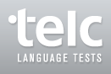
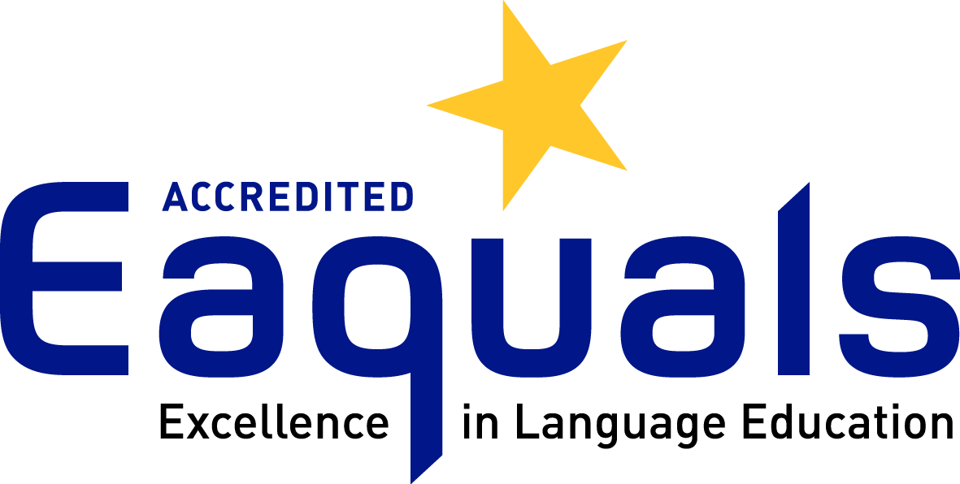
Address: Raina bulv. 31, Riga, Latvia, LV – 1050
Tel: + 371 67844499, + 371 29284480
E-mail: russian@durbe.edu.lv
Skype: noradurbe; jelena.ozola
www.russian-academy.com

